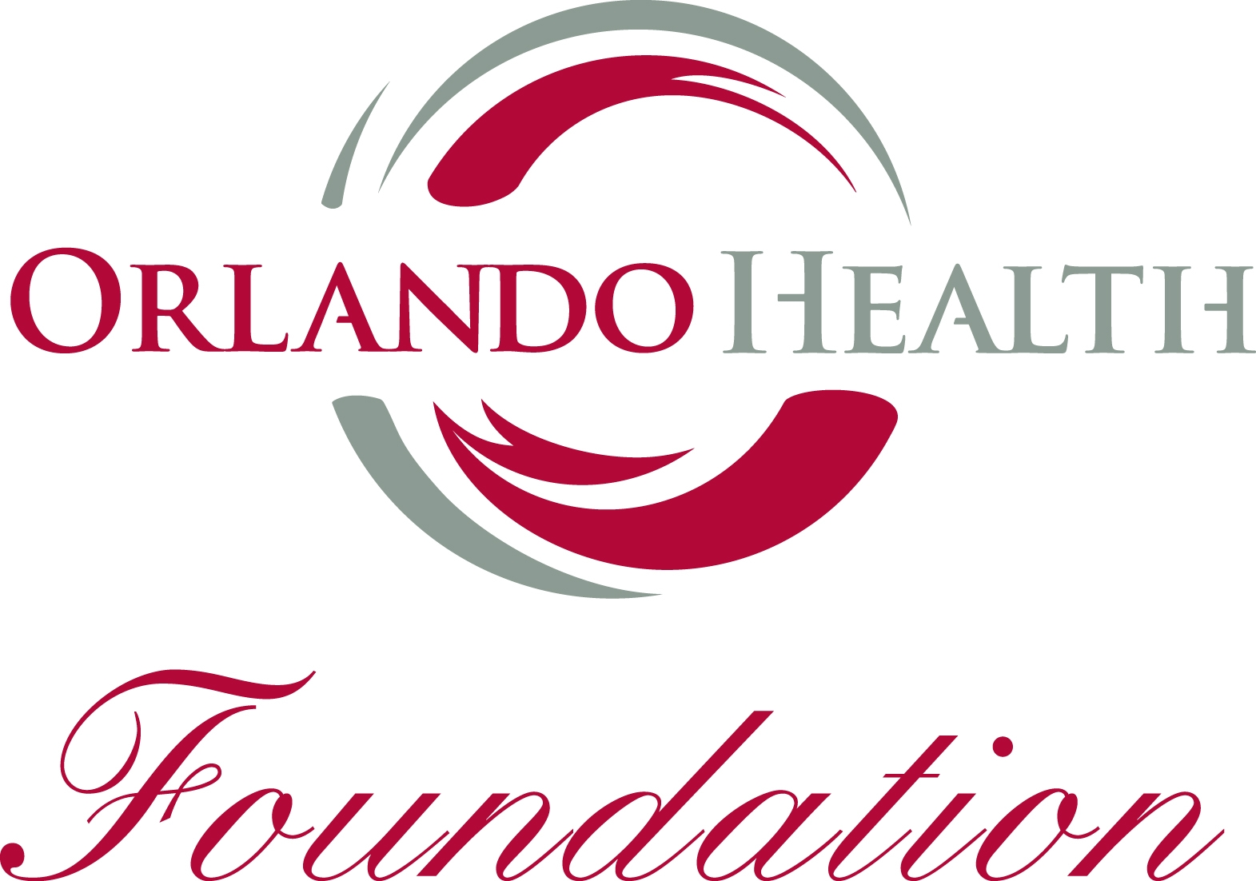

Gift Annuity Application

I. I apply for a Gift Annuity to be issued in the name of:

(Mr.)
(Mrs.)
(Miss)__________________________________________Birth Date__________________
Month Day Year
Street Address_____________________________________ ( ) ______________________
Telephone Number
City________________ State____________ Zip __________ __________________________
Social Security Number

II. The property to be exchanged for the Gift Annuity is: ________________________________

__________________________________________________________________________

(If cash, please state amount. Otherwise, describe property to be exchanged and the date of purchase, your “cost basis,” and the estimated or actual value. If more space is needed, please use the reverse side of this Application. If some or all of the above information is unknown, complete the balance of the Application. A foundation representative will contact you if additional information is needed.)

III. If the Annuity is to be for the life of two persons, please supply the following information about
the survivor:

(Mr.)
(Mrs.)
(Miss) ________________________________________ Birth Date_______________
If a woman and married, please use given name and husband’s surname Month Date Year
Street Address _______________________________________ ( )_______________________
Telephone Number
City_____________ State__________ Zip _________ __________________________________
Social Security Number
Do you wish to retain the right, by Will, to revoke survivor’s interest? (In some cases, this may be advisable to avoid gift taxes. You may return the Application without answering this question, and we will confer with you and your advisors about what is best for you.) ____Yes ____No

IV. Payments are to be made as follows:
____ Payments to begin to accrue immediately upon acceptance of this contract by Orlando Health
_____Payment to be deferred _____ years from acceptance of this contract by Orlando Health (or in the
alternative, payments to begin on) _________________________________________
Month Day Year
Mode of Payment: Wire transfer _____ ACH Direct Deposit____ Check_____

Once payments begin, they are to be made: ____ Annually ____Semi-Annually ____Quarterly

I understand that the Gift Annuity Agreement is irrevocable. Applications received by Orlando Health up to the 15th day of the month will be dated as of the first day of the month and applications received subsequent to the 15th will be dated the first day of the following month.

An annuity contract shall not be complete until this Application is accepted by Orlando Health.

Signature of Applicant______________________________________ Date___________

Accepted By:________________________________________
Orlando Health

